Steps to create another mailbox in Outlook

1. To create another mail box in outlook, follow the steps involved.
2. Click and open outlook app
3. From the home page, click tools option (refer Figure :1)

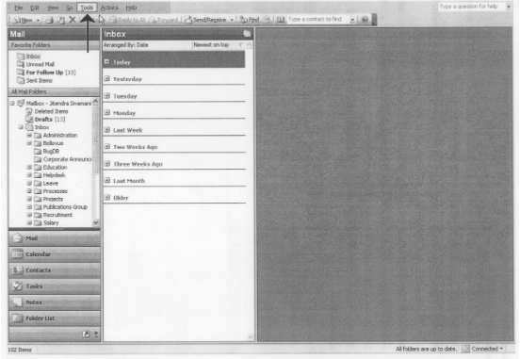

Figure 1

1. Right click to explore more options and go to e-mail accounts( refer Figure:2)

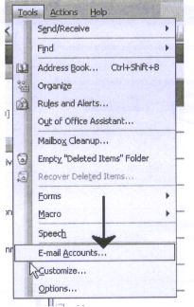

Figure:2

1. It directs to new window, select option View or change existing e-mail accounts and click Next option in middle bottom of the page.( refer figure:3)

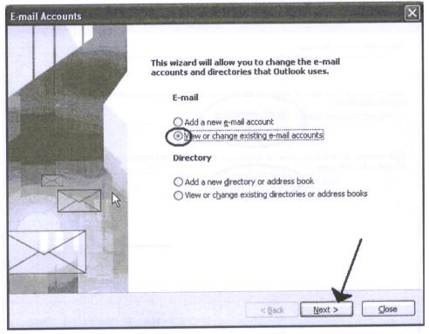

Figure:3

1. It directs to the E-mail account window, select Microsoft exchange server and click change option. (refer figure:4)

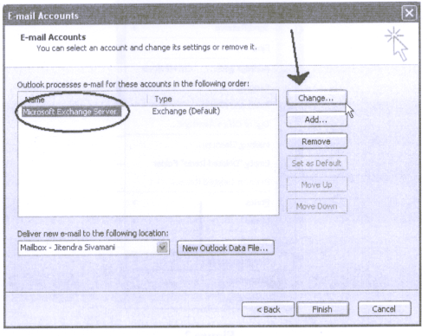

Figure:4

1. It directs to the Exchange server settings, check the email id option and click more setting option.( refer figure:5)

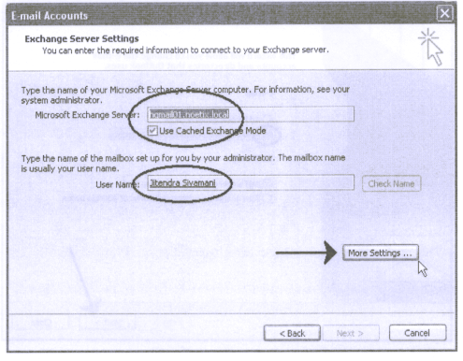

Figure:5

1. It directs to the Microsoft exchange server window, click Advanced option, check “automatically detect connection state” option and click OK(refer figure:6)

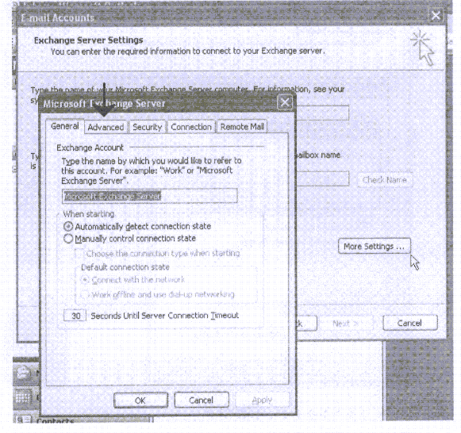

Figure: 6

1. From Microsoft exchange server window, click remote mail option click add(refer figure:7)

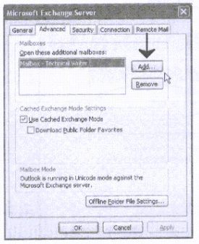

Figure :7

1. It appears a small window ( refer figure:8)

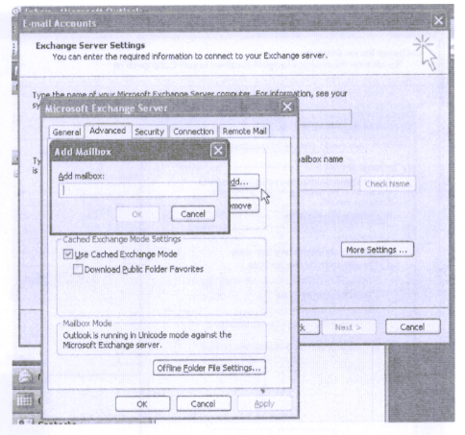

Figure: 8

1. Add another userrname and click ok to finish the peocess (refer figure:9)

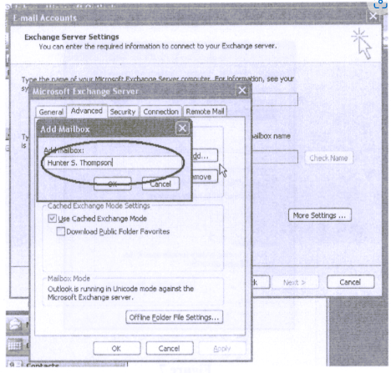

Figure:9